Exploring Spectroscopy at ESRF-EBS through beamline ID24

O. Mathon¹, and K. Lomachenko¹

¹European Synchrotron Radiation Facility, Grenoble, 38000, France

Presenting author email: mathon@esrf.fr

ID24 is a beamline at the ESRF dedicated to hard X-ray Absorption Spectroscopy (XAS). It is powered by an undulator source and consists of two branches: ID24-ED and ID24-DCM.
ID24-ED is an energy-dispersive XAS beamline optimized for ultrafast measurements, reaching time resolution down to a single bunch (100 ps), enabled by the high photon flux of up to 10¹³ photons/second from the undulator. Its primary application is the study of materials under laser-induced dynamic compression, driven by the High-Power Laser Facility (HPLF).
ID24-DCM is a high-brilliance XAS beamline that utilizes a next-generation scanning Double Crystal Monochromator (DCM) developed at the ESRF. It covers an X-ray energy range from 5 to 45 keV. Taking full advantage of the new Extremely Brilliant Source (EBS) characteristics, this branch combines a high flux (up to 10¹³ ph/s) with a tunable X-ray beam size, ranging from 1×1 mm² down to 500×500 nm² (FWHM).
Following a brief introduction to the ESRF-EBS and spectroscopy activities at ESRF, I will present a detailed overview of the ID24-DCM beamline, developed and optimized specifically for ESRF-EBS. I will highlight the newly developed DCM and the efforts made to improve synchronization between the monochromator and the undulator source. Finally, I will showcase the capabilities of this new beamline through recent technical achievements and scientific results.

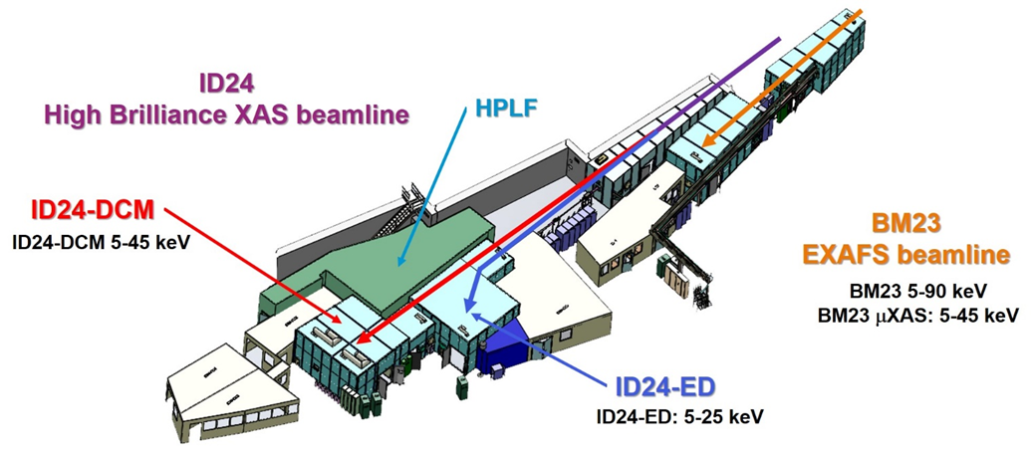
Figure 1: BM23 and ID24, a beamline complex dedicated to XAS at ESRF

